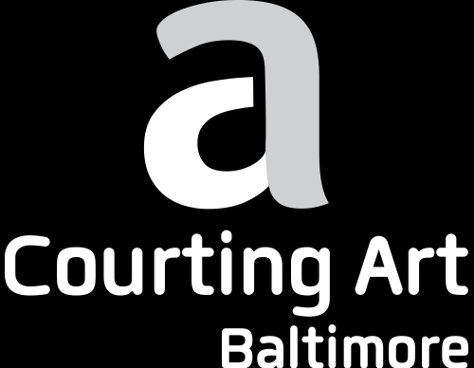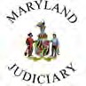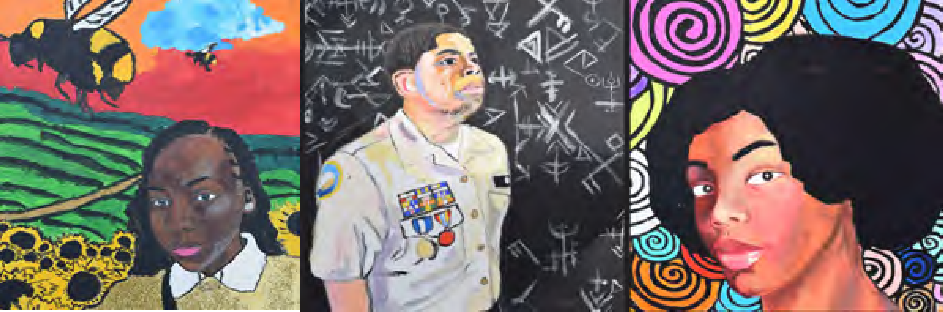

OPEN CALL FOR ART
The competition supports Baltimore’s young artists and connects the local and legal communities. Hosted by the District Court of Maryland in partnership with Arts Every Day and Baltimore City Public Schools, the contest gives young artists the chance to show off their talents and receive scholarship opportunities.

THEME My Baltimore
WHO Baltimore City public high school students who live in Baltimore City.
REQUIREMENTS Two-dimensional drawing, photograph, painting, or mixed media artwork ready to be hung (not free standing). Maximum size: 18” x 24.”
See courtingartbaltimore.com for additional information.

DATES Thursday, April 20, 2023 — Deadline for submissions
Please contact Betty Gonzales, betty@artseveryday.org
Thursday, April 27, 2023, at 5:30 p.m. — Exhibition Reception, Baltimore City Public Schools District Office (All submissions will be displayed; In-person event TBD).

Wednesday, May 17, 2023, at 6:00 p.m. — Awards Reception for Finalists,
Baltimore City District Court, Eastside Courthouse (Only finalists’ artwork will be displayed).

PRIZES Up to $20,000 in total scholarships will be awarded to the top artists, placement at a Maryland Institute College of Art’s Young People’s Studio, art supplies, and long-term display of artwork at the Baltimore City District Court, Eastside Court house. Top works demonstrate exceptional artistic skill, correlate to the theme, and address the goals of the Courting Art.

INTERESTED?
All entrants must submit an entry form (see reverse side) with their submission.
The winning artwork will be reproduced and revealed at an awards reception on May 17, 2023, at the Eastside District Courthouse, where it will remain on long-term display. For information and to submit your entry, visit artseveryday.org/courting-art-baltimore, or contact Betty Gonzales at betty@artsev- eryday.org (410.703.8985).

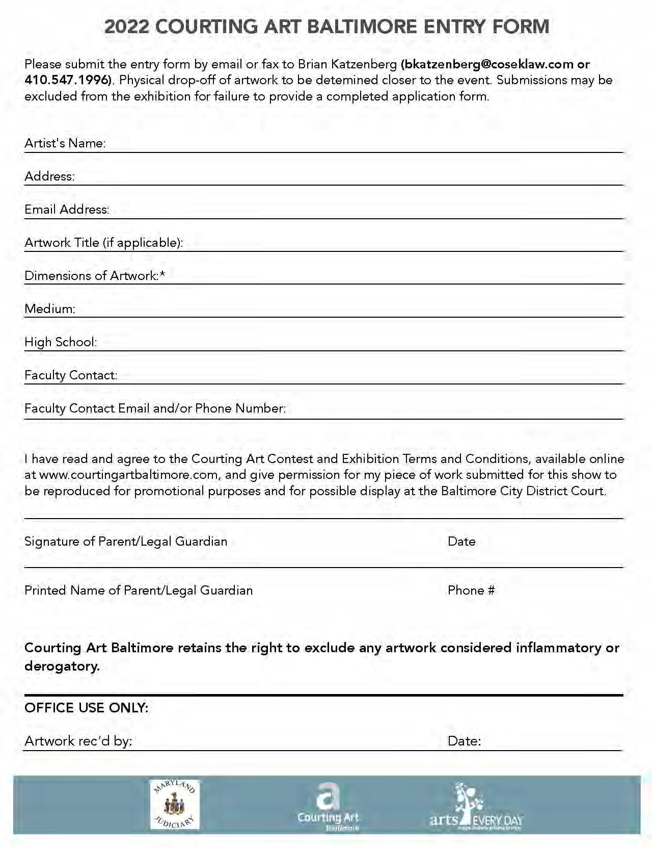2023 COURTING ART BALTIMORE ENTRY FORM
Please submit the entry form by email to Betty Gonzales (betty@artseveryday.org).
Physical drop-off of artwork may take place between
April 11-20, 2023 at Baltimore Unity Hall, 1505 Eutaw Place, Baltimore, MD 21217.

